Ethical Assurance and Certification of Machine Learning Algorithms (MLA) Under DO-178C

Prepared by: Oliver Haythornthwaite
Date:28/05/2026

Document Version Information
Revision Number | Reason | Document Issue | Author
0.1 | Initial Draft | N/A | O Haythornthwaite

Ethical Assurance and Certification of Machine Learning Algorithms (MLA) Under DO-178C
Abstract
The certification of airborne software for safety-critical applications relies upon planned, auditable evidence that demonstrates requirements satisfaction, configuration control, verification independence and closure of safety objectives. For MLA-enabled functions, the same evidential discipline must be retained, with additional evidence addressing data provenance, model behaviour, explainability, robustness, security and operational drift [R1, R2, R8-R13].
The certification and assurance of ML systems hold strong parallels with traditional software assurance, such that established safety-critical approaches should be maintained from the outset. The central assurance claim is that an AI/ML component must not be treated as a special exception to established engineering disciplines. It must instead be controlled as an item within a system safety case, constrained by deterministic architecture at the system boundary, verified by evidence appropriate to data-driven behaviour, protected against cyber and adversarial influence, governed across its lifecycle, and monitored in operational service [R1, R2, R7-R13]. Where these controls cannot be demonstrated at the required level of confidence, the MLA function should be de-scoped, downgraded, isolated, replaced by conventional logic, or limited to advisory/non-safety-critical use.
The default position taken in this report is that model training is offline, that the trained model and all supporting datasets, tools and parameters are under explicit configuration control, that operational learning is not permitted unless a specific certification basis has been agreed, that MLA output is bounded by deterministic safety constraints, and that independent monitoring and human-in-the-loop or human-on-the-loop fallback modes are applied only where their feasibility has been demonstrated [R1, R4, R7-R13]. MLA integration must be justified by quantifiable safety or mission-effectiveness benefit. Claims of accuracy, robustness, reliability, explainability, safety and bias control must be supported by auditable evidence. MLA must be certified as part of the integrated system-of-systems safety argument. A comprehensive understanding of certification-authority concerns must be established through early engagement.

Purpose, Scope and Applicability
This document applies to supervised, offline-trained ML models, statistical classifiers, perception models, decision-support models, anomaly detectors and optimisation algorithms used in, or influencing, safety-related aviation functions. It also applies to ground support, mission planning, maintenance, simulation, digital-assistant and training systems where AI/ML outputs can indirectly influence airworthiness, operational safety, flight safety, maintenance decisions or command decisions [R1, R2, R5, R8, R11-R13].
It does not approve adaptive in-service learning, autonomous lethal decision-making, uncontrolled online model update, opaque third-party foundation-model dependence, or any AI/ML deployment without an agreed certification and safety basis. These additional features and uses pose additional assurance, safety, ethical and legal challenges and are outside the scope of this initial case [R1, R8, R11-R13].
For the purposes of this report, “safety-critical” is used to describe any function, system behaviour, dependency or operational context in which erroneous AI/ML behaviour, misleading output, unavailable output, delayed output, excessive automation reliance, degraded explainability, data poisoning, adversarial influence or integration failure could contribute to a hazardous, major, severe-major or catastrophic condition [R2, R4, R8-R10].

Policy Context
The regulatory context within which this report has been produced includes MOD policy, domain regulation, system-safety standards, software-assurance standards, cyber/security controls, quality and configuration management, and authority-specific AI/ML guidance. Reference identifiers in this table (for example, [R1]) link assurance claims to the relevant policy or guidance sources.
Ref | Source | Use in this document
R1 | MOD JSP 936, Dependable Artificial Intelligence in Defence | Principal MOD policy framework for safe and responsible adoption of AI in defence. Requires dependable AI governance, lifecycle controls, ethics, safety, security, quality and human oversight appropriate to risk.
R2 | MOD JSP 376, Defence Acquisition Safety Policy | Pan-domain acquisition safety policy. Requires systematic safety management, hazard elimination/reduction and justified safety assurance throughout acquisition.
R3 | MOD JSP 815, Defence Safety Management System | Overarching Defence SMS framework and direction. Provides organisational safety-management expectations, continual improvement and safety accountability.
R4 | MOD JSP 912, Human Factors Integration for Defence Systems | Mandates HFI in Defence acquisition projects. AI/ML systems must address human-machine teaming, workload, trust, mode awareness, training, error management and supervision.
R5 | MOD JSP 939, Defence Policy for Modelling and Simulation | Relevant where simulation, synthetic data, digital twins, SIL/HIL benches or model-based evidence are used as certification or safety evidence.
R6 | MOD JSP 940, MOD Policy for Quality | Quality management and assurance for acquisition, engineering and logistics support, quality planning and audit evidence.
R7 | MOD JSP 945, MOD Policy for Configuration Management | Configuration-management policy and guidance for requirements, datasets, models, code, tools, evidence, baselines, change control and release integrity.
R8 | MAA Regulatory Publications and MAA/RN/2025/04 | MAA expectations for AI within systems and equipment subject to MRP design assurance processes, including early engagement and sufficient evidence for assurance.
R9 | DO-178C and supplements DO-330, DO-331, DO-332 | Airborne software assurance baseline, tool qualification, model-based development and object-oriented technology considerations. Does not by itself fully assure learned behaviour.
R10 | ARP4754A/B and ARP4761 | System development and safety assessment principles: FHA, PSSA, SSA, requirements allocation, architecture assurance and safety-case closure.
R11 | EASA AI Concept Paper Issue 2 and AI Roadmap | Learning assurance, AI explainability, ethics-based assessment and AI/ML constituent thinking for aviation AI applications.
R12 | FAA Roadmap for Artificial Intelligence Safety Assurance | US regulator roadmap recognising the need for AI safety-assurance methods, sufficient artefacts and staged adoption for aircraft/avionics AI.
R13 | UK CAA AI Principles and AI Strategy for Aviation | Principles-based AI approach covering safety, security, privacy, transparency, human oversight and regulatory capability for AI in aviation.
Table 1 - Policy Context
Policy Traced Arguments
Adoption and governance: MLA should be treated as a controlled safety item, not as an exception to engineering discipline [R1-R3, R8].
System safety and certification basis: FHA/PSSA/SSA, requirements allocation and architecture assurance remain the primary route to a credible safety case [R2, R8-R10].
Data and model assurance: dataset provenance, representativeness, bias analysis, robustness, explainability and ODD limits are necessary additions to conventional software evidence [R1, R6, R7, R11-R13].
Human factors: any reliance on human oversight must be supported by evidence for workload, trust calibration, mode awareness, training and timely intervention [R4, R11, R13].
Tooling, quality and configuration: datasets, trained models, tools, generated artefacts, evidence packs and release baselines must be controlled, and tools should be qualified where their outputs are relied upon for certification [R6, R7, R9].
Simulation, SIL/HIL and flight-test evidence: synthetic data, simulation, digital twins and test-benches should be justified as evidence sources and linked to system-level verification [R5, R9-R12].
Continued airworthiness and operations: operational monitoring should detect drift, ODD excursions, abnormal confidence behaviour, fallback events and changes that may invalidate certified assumptions [R1, R8, R11-R13].

Preface: Design, Implementation and Verification of Software
DO-178C defines objectives across planning, requirements, design, implementation, verification, configuration management and quality assurance, but does not certify software in isolation. It provides objectives and guidance for producing software life-cycle evidence that can support approval of airborne systems and equipment within an agreed certification basis. It requires evidence that software life-cycle processes satisfy the applicable objectives, including requirements-based testing, structural coverage analysis, independence where required, configuration management and quality assurance [R9]. For a Level A software item, modified condition/decision coverage (MC/DC) is one of the structural coverage expectations, but it is not a substitute for demonstrating that requirements are complete and correct.
MLA implementation processes deviate from traditional approaches because part of the behaviour is learned from data rather than explicitly specified in conventional source code. A frozen model may produce repeatable inference results for a given input and environment, but its correctness cannot be inferred from code coverage alone [R9, R11, R12].
Traditional structural coverage metrics remain relevant for deterministic supporting software, but they are not sufficient to characterise learned model behaviour. Additional assurance evidence should address dataset coverage and representativeness, operational-design-domain coverage, model architecture and parameter baselines, robustness, uncertainty, explainability, regression behaviour and system-level safety constraints [R1, R9, R11-R13].
DO-330 provides tool qualification guidance, and remains highly applicable in the selection of applications and code generators, which are supplied with DO-330 qualification packs. A pertinent example here is the KCG code generator utilised by SCADE.
DO-331 provides model-based development and verification guidance. It should not be treated as ML-specific guidance, but it can support model-based engineering artefacts, traceability and verification planning around an MLA-enabled system when used within an agreed certification basis [R9].
DO-332 provides guidance for object-oriented technology and related techniques. It is relevant where object-oriented software is used in the MLA-enabled system, but it does not itself provide assurance of learned model behaviour. Its value is in ensuring that the conventional software surrounding the model remains analysable, traceable and verifiable [R9].
Preface: System Design and Safety Considerations
ARP4754A/B provides system development guidance for civil aircraft and systems, while ARP4761 provides safety assessment guidance including FHA, PSSA and SSA. Together, they support a top-down safety-driven development approach in which hazards, requirements, architecture and verification evidence are progressively linked.
Adapting processes which have been leveraged to result in compliant systems, is clearly the sensible approach, from the perspective of cost reduction and the likelihood of success. Therefore, a high level (non exhaustive) process flow has been provided in the figure below.
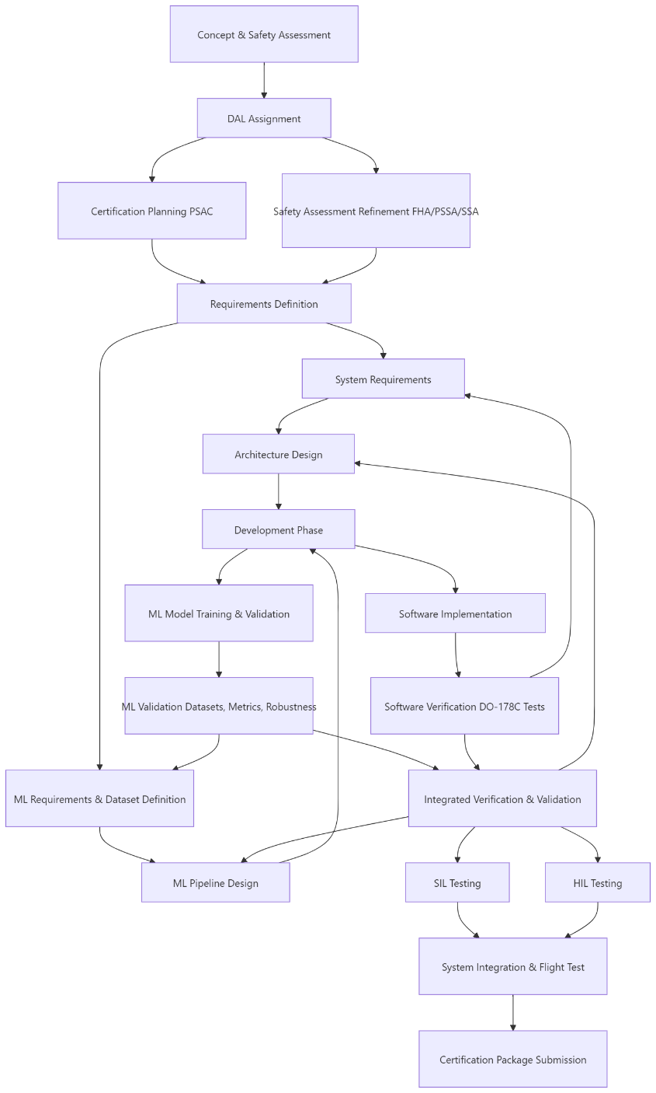
Figure 1 - High Level Certification Flow
The process shown in Figure 1 should not be interpreted as a simple linear schedule. First-of-type MLA assurance activities are likely to introduce atypical dependencies, delays and review points. These include early communication of intent, agreement of platform assumptions, definition of certification basis, identification of authority concerns, and funding of evidence-generation activities. Early authority engagement is therefore a core dependency, not a late-stage review activity.
Assessing and Ensuring Safety
A sequential Safety Assessment Process (SAP) is presented in Figure 2. The ML specific addition is an explicit stage in which MLA hazards are identified and evaluated before safety functions are allocated and the system safety assessment is closed [R2, R8, R10].
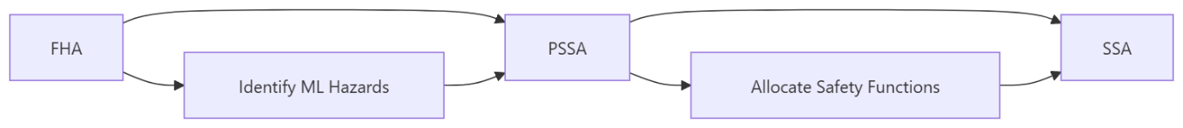
Figure 2 – SAP
Traditional requirements engineering draws upon existing platform requirements and approaches, to reduce costs associated with novel designs, off the shelf components and software modules are integrated, according to this approach.
A project-specific assurance process should be developed and agreed with the relevant authority early in the programme. It should define how requirements, data requirements, model-performance requirements, safety requirements, security requirements and human-factors requirements will be written, reviewed, traced and verified. Minimum model metrics such as accuracy, precision and recall are useful only when linked to hazards, operational constraints, ODD assumptions and failure-mode analysis [R1, R4, R8, R11-R13].
Once such requirements are formed, it is imperative that the practise of traceability is maintained through the enforcement of a bi-directional traceability model.
Further to these traditional methods of assurance, there is a need to address the novel considerations introduced by MLA. Deviations from stated requirements, weak requirement wording, unverified data assumptions and unbounded model behaviour all increase assurance risk. Existing mechanisms for requirements validation, verification and traceability should therefore be upheld and expanded to include data and model evidence [R1, R7-R13].
The assurance of MLA should be applied within the scope of the integrated system. Of primary importance is the resilience of the system to erroneous, misleading, stale, unavailable or adversarially influenced MLA output. Where identified assurance risks could result in unexpected behaviour of a safety-critical system, MLA must not be adopted unless the architecture can preserve safety and the residual risk is demonstrably acceptable. If a conventional system has historically met the safety need, MLA integration should be justified by a measurable reduction in risk, improvement in resilience or mission benefit that cannot be achieved through a safer conventional means [R1, R2, R8, R10-R13].
Additional consideration should be given to the Design Assurance Level, criticality of the function, level of autonomy, exposure to operational variability and strength of the surrounding safety architecture. A suitability matrix can be used to show whether an MLA integration is supportable within the integrated safety-critical system [R1, R2, R8, R10-R13] as illustrated in Table 2.
Factor | Low Concern | Medium Concern | High Concern
Function Criticality | Advisory | Influences Operator Action | Affects Control
Model Authority | Recommendation | Bounded Decision | Autonomous Action
Explainability | Clear Rationale | Partial Rationale | Opaque Output
ODD Containment | Well defined | Partially Monitored | Poorly Bounded
Fallback | Deterministic and Verified | Verified Human Fallback | No Fallback
Table 2 - Example Suitability Matrix
Architecture Design
MLA components should be designed as modular software/system items with explicitly defined interfaces, allocated requirements, constrained inputs and bounded outputs. Isolation, loose coupling, partitioning and deterministic safety envelopes remain fundamental aspects of safety-critical architecture design [R7-R10].
As with traditional systems, safety-critical redundancy and partitioning should be employed where required by the safety assessment. Fallback, rejection and degraded-mode processing should be applied to mitigate noisy inputs, out-of-distribution data, low-confidence outputs, unavailable outputs and model failure modes [R2, R8-R11].
Bounding a model within an interface that exposes only safely interpreted information, such as enumerated states, mapped classes or constrained confidence bands, increases the likelihood that the system-level behaviour can be deterministically verified. Although continuous numerical outputs can be range-limited, range limits alone do not demonstrate contextual validity or safe recovery. The safety case should therefore include safety and security requirements, interface constraints, runtime monitors, rejection logic and verified fallback paths for MLA failure modes [R7-R11, R13].

Model Implementation
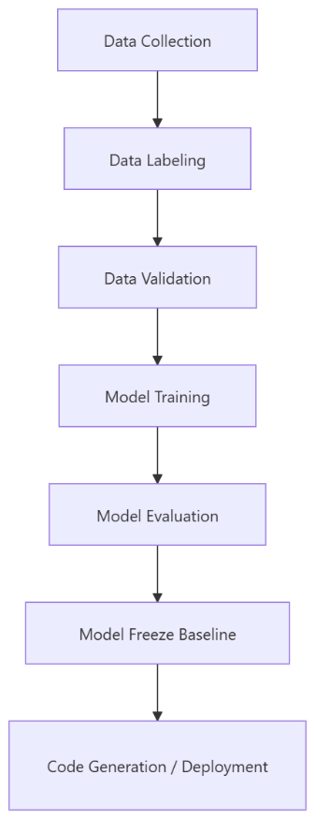
Sensor suites and test benches provide the capability to evaluate deployed model performance on target-equivalent hardware. Functional equivalence between development and target environments should be demonstrated for the configured model/software item, or differences should be analysed and verified. Portability remains important, particularly where MLA requires non-traditional airborne computing resources such as GPUs, TPUs or high-memory embedded processors [R6-R10].
Successful approaches will require thoroughly designed, validated and configuration-controlled datasets, such that empirically justified confidence is held in data quality, representativeness, provenance and legality. Present biases must be identified, justified where operationally necessary, and examined through the lenses of operational safety, ethical impact and capability [R1, R6, R7, R11-R13].

As highlighted by the MOD dependable-AI policy context, AI adoption may introduce tensions between capability ambition, delivery timelines, assurance evidence and risk ownership. A project seeking to certify airborne-deployed AI must therefore establish realistic timelines and governance from the outset. Analyses and verification activities should not be compressed in a way that reduces safety, security, ethical or certification confidence [R1, R2, R8].
Within the development lifecycle, repeatability is a core component of assurance. If a model is trained or tuned in an undocumented manner, the certification argument is weakened because the relationship between data, tooling, parameters, environment and observed behaviour cannot be reconstructed. Any model freeze must therefore be preceded by a repeatable, configuration-controlled pipeline for generating the trained model and associated evidence. This ensures that queries around dataset quality, legality, content, bias and model behaviour can be answered from recorded artefacts [R1, R6, R7, R9, R11-R13].
During development, attention should be provided towards the enforced MLOps strategy and pipeline, a certification evidence system may be employed (such as the CAS) to verify the existence and suitability of certification evidence, to form part of this pipeline. It is imperative that such a facility is upheld, the common pitfalls of technological debt, sometimes accrued through fast paced DevOps based deliveries, must not be allowed to build, should this technical debt compromise verification/validation of the MLA model.
Therefore it is my view that such an MLDevOps pipeline must be thoroughly considered and implemented prior to the commencement of any development, as such a pipeline would provide suitable metrics for the evaluation of training data, thereby providing data quality assurances at an early stage, in a regressive manner. An example of such a pipeline is documented below, however it is recognised that existing workflows may be more suited to specific applications.

MLDevOps Process Considerations
A structured MLDevOps approach should be established prior to substantive model development. The process should not be treated as a conventional rapid DevOps pipeline in which incremental performance improvement is the primary objective. Rather, it should be designed as a controlled assurance pipeline, where each development activity produces auditable evidence suitable for certification review.
For the purposes of this report, the process may be considered across three interrelated domains: ML, DEV and OPS.
ML
The ML domain concerns the creation, training, validation and control of the model and the data upon which it depends. Activities within this domain should include:
• configuration and control of training, validation and test datasets;
• documentation of dataset provenance, ownership, licensing and suitability;
• analysis of data distribution against the intended operational design domain;
• identification of gaps, imbalance, bias, under-representation and over-representation within the dataset;
• assessment of whether identified biases are operationally acceptable, safety-relevant or ethically problematic;
• definition of model architecture, training parameters, hyperparameters and performance metrics;
• analysis of overfitting, underfitting and generalisation behaviour;
• evaluation of predictive performance against requirements-derived metrics;
• regression testing against previous model baselines;
• robustness testing against noise, degraded inputs, edge cases and adversarially influenced data;
• documentation of model limitations, confidence behaviour and known failure modes.
The objective of this domain is not simply to produce a model that performs well against a test set. It is to produce a model whose behaviour is sufficiently understood, bounded, repeatable and evidenced for use within a safety-related system. All training activity should therefore be repeatable, configuration controlled and capable of being reconstructed from recorded data, tooling, parameters and environment definitions.
DEV
The DEV domain concerns the engineering of the MLA-enabled system, including integration with conventional software, deterministic monitors, interfaces, safety mechanisms and platform architecture. Activities within this domain should include:
• planning for the creation of the integrated model/software/system item;
• allocation of requirements to the MLA component and its surrounding architecture;
• development of interface definitions, input constraints and output mappings;
• implementation of preprocessing, post-processing and monitoring logic;
• integration of the MLA component with deterministic safety controls;
• development of fallback, degraded-mode and override mechanisms;
• verification of software functionality against requirements;
• verification of system behaviour when the MLA produces invalid, uncertain or unavailable outputs;
• packaging of the model and software artefacts for deployment;
• demonstration of portability across development, test and target-equivalent environments;
• configuration control of all software, model, data and toolchain artefacts.
The DEV domain should ensure that the MLA is not treated as an isolated algorithmic component, but as one part of a wider engineered system. Particular attention should be given to model system boundaries, since this is where deterministic safety constraints, interface controls and runtime monitors may be applied. The model may remain statistical in nature, but the behaviour exposed to the safety-critical system should be bounded, interpretable and managed through conventional engineering controls.
OPS
The OPS domain concerns release, deployment, monitoring, sustainment and continued certification of the MLA-enabled system. Activities within this domain should include:
• release of model/software baselines through formal change control;
• incremental delivery only where each release is supported by regression evidence;
• configuration of deployable software artefacts, model files, datasets, tools and evidence packs;
• maintenance of release records linking deployed artefacts to certification evidence;
• monitoring of deployed performance against certified assumptions;
• detection of drift, degraded performance, abnormal confidence behaviour and operational data outside the ODD;
• recording of fallback, rejection, override and failure events;
• sustainment of the evidence base throughout the lifecycle;
• assessment of retraining, patching or model replacement as formal configuration changes;
• gaining, maintaining and, where necessary, revising certification approval.
The OPS domain should be designed to prevent uncontrolled change. Any alteration to the trained model, preprocessing logic, monitoring threshold, dataset, toolchain or deployment environment may affect the validity of the certification evidence. Such changes should therefore be assessed for impact, subject to regression testing and incorporated into the safety case before operational release.
Verification of the Model and Integrated System
Verification should be undertaken progressively, from isolated model assessment through to system-level and operationally representative evaluation. It is not sufficient to validate the MLA solely against statistical performance metrics. Verification must also demonstrate that the integrated system behaves safely when the model is correct, incorrect, uncertain, unavailable or exposed to unexpected inputs.
Unit Testing
Unit testing should be applied to supporting software functions, including preprocessing, feature extraction, input validation, post-processing, output mapping, confidence handling and monitor logic. These tests should verify that deterministic elements of the system behave in accordance with their requirements.
For MLA components, unit-level assessment should also consider repeatability of inference, correct loading of the configured model, correct handling of boundary values, rejection of malformed input and consistency between development and target-equivalent execution environments.
Software-in-the-Loop Testing
Software-in-the-loop testing should be used to evaluate the MLA component within a representative software environment. This should include nominal scenarios, edge cases, degraded data, simulated sensor failures, out-of-distribution inputs and regression datasets.
The purpose of SIL testing is to demonstrate that the model and its surrounding software operate correctly before hardware-specific effects are introduced. SIL evidence should also be used to support regression testing between model versions and to verify that changes in model performance have not introduced new unsafe behaviours.
Hardware-in-the-Loop Testing
Hardware-in-the-loop testing should be used where timing, processing constraints, memory limitations, sensor characteristics, bus behaviour or target hardware effects may influence system performance. This is particularly relevant where MLA deployment requires non-traditional airborne computing resources, such as GPUs, TPUs or high-memory embedded processors.
HIL testing should demonstrate that the deployed configuration performs within required timing, availability and resource constraints. It should also demonstrate that safety monitors, fallback behaviours and degraded modes remain effective on target-equivalent hardware.

Flight Testing
Flight testing should be used to validate the MLA-enabled system under operationally representative conditions. It should not be used as the primary means of discovering basic model failure modes, which should already have been identified through analysis, simulation, SIL and HIL activity.
Flight test activity should focus upon confirming real-world performance, validating assumptions made during earlier verification stages, assessing human-machine interaction and collecting certification evidence. Where the MLA influences safety-related functions, flight testing should be planned conservatively, with clear test boundaries, fallback procedures, independent monitoring and defined abort criteria.

Tooling Qualification
Tool qualification should be considered wherever a tool contributes to certification evidence, generates software or model artefacts, transforms data, or produces outputs that cannot be fully verified by independent manual or automated means. The need for qualification should be determined by the tool’s role, the criticality of the system function and the degree to which an undetected tool error could contribute to unsafe behaviour.
When Tool Qualification May Be Required
Additional tool qualification may be required where:
• tool output cannot be fully verified by subsequent process steps;
• a tool generates deployable code, model artefacts or configuration files;
• a tool performs dataset transformation, labelling, augmentation or filtering;
• a tool produces verification evidence relied upon for certification;
• a tool automates requirements, traceability or coverage analysis;
• a tool error could mask a defect in the model, software or safety case.
ML-Relevant Tools
ML-relevant tools may include:
• training frameworks;
• data preprocessing pipelines;
• data labelling and annotation tools;
• synthetic data generation tools;
• model conversion and optimisation tools;
• code generators;
• simulation environments;
• test orchestration tools;
• coverage, robustness and performance-analysis tools;
• certification evidence management systems.
The qualification argument should consider not only conventional software tools, but also tools used to construct the evidential basis for the MLA. For example, a data preprocessing tool that silently alters feature distributions may have a material impact upon model behaviour, even though it does not directly generate airborne code.

Example Tool Qualification Considerations
As an indicative position:
• training tools may require a qualification approach appropriate to the extent to which their outputs can be independently verified;
• model conversion or code generation tools may require stronger qualification where they produce deployable artefacts;
• analysis tools may require qualification where their outputs are directly credited as verification evidence;
• evidence-management tools may require assurance where they are used to demonstrate traceability, completeness or compliance status.
Any proposed Tool Qualification Level should be agreed in the context of the certification basis, the applicable safety objectives and the extent to which downstream verification can detect tool-induced errors.

System Integration and Flight Testing
System integration and flight testing should demonstrate that the MLA-enabled system performs safely and predictably within the wider aircraft or aviation system. The objective is not only to confirm model performance, but to demonstrate that the system architecture remains safe when model performance is degraded or incorrect.
Objectives
The primary objectives should be to:
• validate real world performance against requirements and assumptions;
• demonstrate fail safe and fail operational behaviours where applicable;
• confirm the effectiveness of runtime monitoring and fallback logic;
• assess the system’s response to invalid, uncertain or unavailable MLA outputs;
• verify timing, latency, availability and resource behaviour;
• evaluate operator workload, trust, mode awareness and intervention capability;
• collect certification evidence under representative operational conditions.
Key activities should include:
• fault injection scenarios;
• degraded sensor and degraded data testing;
• skewed distribution input scenarios;
• adversarial and noisy input assessment where applicable;;
• fallback and override demonstration;
• regression testing against prior baselines;
• recording of operational data for certification evidence;
• assessment of post-flight data against safety and performance claims.
The results of integration and flight testing should be fed back into the safety case. Where testing reveals previously unidentified failure modes, these should be captured within the hazard log, assessed for severity and likelihood, and mitigated through design change, operational limitation, monitoring, retraining or de-scoping.

Certification Package
The certification package should provide a coherent and reviewable body of evidence demonstrating that the MLA-enabled system satisfies its certification basis. It should be structured so that each claim can be traced to requirements, design artefacts, verification evidence and safety arguments.
Core Contents
The package should include:
• certification plans, including PSAC, Tool Qualification Plan and Configuration Management Plan where applicable;
• system, software, safety, security and human-factors requirements;
• design descriptions and architecture artefacts;
• interface control documentation;
• verification and validation plans;
• verification results, including unit, SIL, HIL and flight-test evidence;
• configuration-management records;
• tool qualification evidence;
• quality-assurance records;
• safety assessments, hazard logs and safety-case material;
• authority engagement records and issue-closure evidence.
ML-Specific Additions
In addition to conventional certification artefacts, the package should include:
• dataset documentation and provenance records;
• dataset representativeness and bias analysis;
• training, validation and test-set definitions;
• model architecture and training configuration records;
• hyperparameter and environment baselines;
• model validation reports;
• robustness, uncertainty and confidence-behaviour assessments;
• explainability evidence proportionate to the criticality of the function;
• ODD definition and limitation statements;
• runtime monitoring and fallback evidence;
• assurance case for known model limitations;
• retraining and model-change control process.
The certification package should make clear which evidence applies to which configured release. Evidence generated for a previous model, dataset, training run or deployment environment should not be assumed applicable unless equivalence has been demonstrated and recorded.
ML-Specific Considerations
Explainability Gap
A significant certification challenge arises from the limited explainability of some MLA techniques. Where the internal basis for a model output cannot be fully understood, the safety case must provide alternative evidence that the model's behaviour is sufficiently bounded, predictable and understandable for the intended use and user community [R1, R4, R11-R13].
Mitigations may include:
• use of inherently interpretable models where practicable;
• use of surrogate models to explain local or global behaviour;
• statistical justification of performance across defined operational conditions;
• sensitivity analysis to identify influential input features;
• confidence scoring and uncertainty estimation;
• explanation of output limitations to operators;
• restriction of MLA authority where explainability is insufficient.
Explainability should be considered in relation to the user and the safety function. A highly technical explanation may support engineering assurance, but may not be sufficient for a pilot, maintainer or operator required to make a time-critical decision. The form of explanation should therefore be matched to the operational context.
Distribution Shift
Distribution shift occurs when operational inputs differ materially from the data used during training, validation or test. This represents a significant assurance risk, since an MLA may continue to produce confident outputs even when operating outside the domain in which its performance has been demonstrated.
Mitigations should include:
• definition of the operational design domain;
• analysis of training and validation data against the ODD;
• detection of out-of-distribution inputs;
• anomaly detection and rejection mechanisms;
• confidence thresholds and uncertainty estimation;
• fallback modes for unsupported conditions;
• continued monitoring of operational data;
• periodic review of whether certified assumptions remain valid.
Where the system cannot reliably detect operation outside the ODD, the MLA should not be credited with safety-critical authority in those conditions.

Runtime Monitoring
Runtime monitoring should be used to constrain MLA behaviour during operation. The monitor should not merely observe model output, but should determine whether the output is valid, timely, sufficiently confident and consistent with system-level safety constraints.
A suitable runtime monitoring approach may be expressed as:
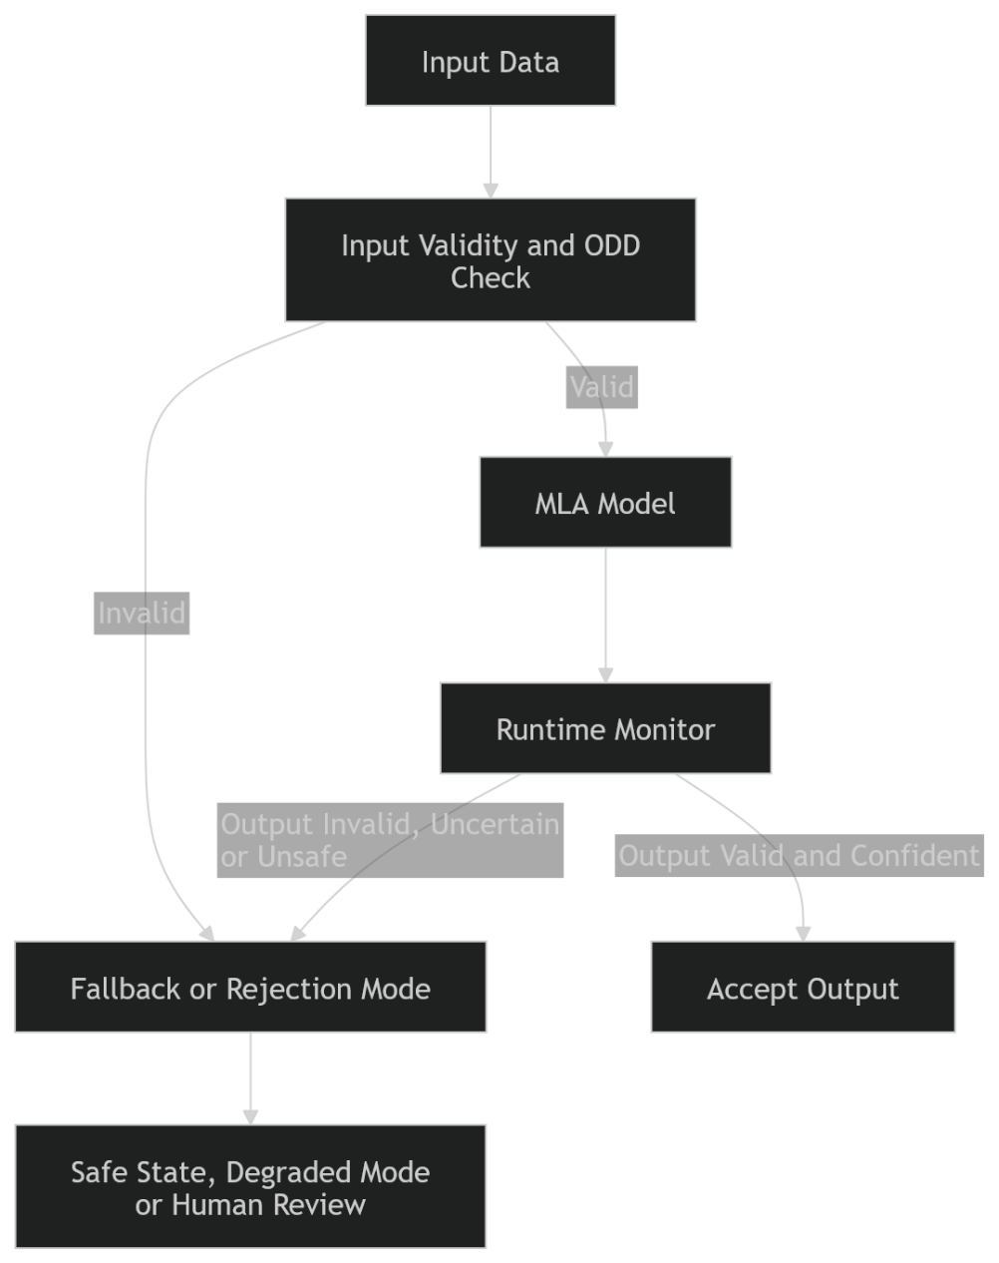
The monitor should consider the validity of input, ODD compliance, model confidence or uncertainty, consistency with physical or logical constraints, timing and latency, agreement with independent sources where available (human in the loop), detection of repeated rejection or degraded behaviour.
Where the monitor rejects an MLA output, the system should transition to a defined safe state, degraded mode, deterministic fallback or human-review path. The fallback approach should be designed and verified as part of the safety architecture, rather than being treated as an operational assumption.
No Online Learning
Online learning should not be permitted for safety-related MLA functions unless a specific certification basis has been agreed and the associated assurance challenges have been resolved. For the purposes of this report, the default assumption is that any retraining, adaptation or model update constitutes a formal configuration change.
This means that retraining should require:
• change impact assessment;
• updated dataset documentation;
• repeatable training pipeline execution;
• regression testing against previous baselines;
• review of safety, security and human-factors impacts;
• update of the certification evidence package;
• authority engagement where required.
This position does not prevent operational monitoring or data collection. It simply prevents unapproved in-service behavioural change. Operational data may be collected to support future model improvement, but any such improvement should be introduced only through controlled development, verification and release activity.

Gaining Certification
During and post completion of these activities, as mentioned within this report, the evidence necessary to demonstrate compliance to certification requirements must be collected and configured.
This may be achieved through the utilisation of a system such as the one provided as an artefact to this report. The CAS should not be considered a passive repository of evidence, but rather an active certification-management mechanism, through which the state of compliance, maturity of evidence, traceability of requirements, configuration of artefacts and residual assurance risk can be continuously understood. Such a system should allow evidence to be structured against the certification basis, safety requirements, system requirements, software requirements, data requirements and model-performance claims. Where evidence is incomplete, stale, insufficiently reviewed, or no longer representative of the configured system baseline, the associated claim should remain open.
It is imperative that the CAS preserves the relationship between the system safety case and the MLA assurance case. The certification argument must not be founded upon generic claims of model accuracy, but upon a structured demonstration that the integrated system remains safe when the MLA performs correctly, degrades, fails, produces misleading output, or is exposed to operational inputs which differ from the training and validation domain.
A suitable CAS should therefore capture, at minimum:
• certification basis and means of compliance;
• system, software, safety, security and human-factors requirements;
• model architecture, training configuration and hyperparameter baseline;
• dataset provenance, legal basis, representativeness, bias analysis and quality records;
• verification and validation results, including regression evidence;
• safety analyses, hazard logs, mitigations and residual risk statements;
• tool qualification evidence, where applicable;
• configuration-management records and release baselines;
• operational monitoring plans and continued-airworthiness evidence;
• authority correspondence, review findings and closure evidence.
The use of such a system would allow certification evidence to be interrogated in a manner consistent with established airworthiness expectations. This is especially important for MLA systems, where a given model behaviour may be dependent upon a large number of artefacts, including training data, preprocessing logic, model architecture, tooling versions, labelling conventions, test data, deployment hardware and runtime monitors. If these items are not bound together through explicit configuration control, it becomes difficult to prove that the evidence being supplied actually applies to the model and system version intended for release.
Continued Airworthiness and In-Service Monitoring
Certification of an MLA-enabled system should not be understood as the end of assurance activity. Due to the statistical and data-dependent nature of MLA behaviour, a greater emphasis must be placed upon continued monitoring, performance drift assessment and operational feedback. This does not imply that the model should learn in service. Rather, it requires that the deployed system is monitored in order to determine whether the certified assumptions remain valid.
Such monitoring should include:
• detection of operational data outside the defined ODD;
• monitoring of model confidence, uncertainty and rejection rates;
• comparison of MLA outputs against deterministic monitors or independent sources where available;
• recording of fallback, override and disengagement events;
• capture of human-machine interaction issues, including overreliance or inappropriate trust;
• periodic review of false positives, false negatives and ambiguous classifications;
• trend analysis for degradation, drift or emergent failure modes.
Where monitoring identifies that the operational environment has materially diverged from the certified assumptions, the MLA function should be restricted, withdrawn, retrained under formal change control, or subject to further certification activity. Any retraining activity should be treated as a configuration change to the certified item, requiring impact assessment, regression testing, safety-case review and authority engagement proportionate to the criticality of the function.
Human Factors and Operational Use
Human involvement must not be treated as a superficial mitigation for MLA uncertainty. Where a human operator, maintainer, pilot, controller or commander is required to supervise, interpret, validate or override an MLA output, the feasibility of that role must be demonstrated through human-factors evidence. This includes consideration of workload, time available, mode awareness, alerting philosophy, training burden, trust calibration and the possibility of automation bias [R4, R11, R13].
It is therefore not sufficient to state that a human remains “in the loop” unless the system design demonstrably enables the human to understand the MLA output, recognise when it may be unsafe, and intervene within the time available. The operator must be provided with appropriate explanation, confidence indication, alerting, fallback logic and procedural support. Where the operational tempo or complexity of the decision prevents meaningful human supervision, the MLA function should not be credited with safety benefit on the basis of human oversight alone.
Security and Adversarial Considerations
MLA introduces additional security considerations beyond those typically associated with conventional software. Data poisoning, adversarial examples, model inversion, model extraction, unauthorised retraining, compromised datasets and manipulation of preprocessing pipelines may all contribute to unsafe behaviour. These risks must therefore be considered as part of the safety case and system-security argument, rather than being isolated from airworthiness assurance [R1, R2, R7, R8, R11-R13].
The security case should demonstrate that:
• training and validation datasets are protected against unauthorised modification;
• labelling and preprocessing pipelines are controlled and auditable;
• model artefacts are cryptographically protected and configuration managed;
• interfaces are constrained to prevent unsafe or malformed inputs;
• adversarial robustness has been assessed against realistic threat models;
• deployed models cannot be altered without authorised release control;
• monitoring exists to detect abnormal inputs, outputs or confidence behaviour.
Where credible adversarial influence can result in hazardous MLA behaviour, either the system must remain safe under such influence, or the MLA must be isolated from safety-critical authority. The presence of an MLA component should never reduce the security burden of the system. Rather, it should increase the requirement for demonstrable control over data, tools, interfaces and operational assumptions.

Conclusion
The certification of MLA within airborne and aviation-influencing systems should proceed from the basis that established safety-critical engineering principles remain valid. MLA does not remove the need for requirements, determinism at the system boundary, configuration control, verification evidence, traceability, safety assessment, tool assurance, human-factors integration or continued airworthiness. It instead introduces additional evidential burdens, particularly in relation to data, model behaviour, explainability, robustness, security and operational drift.
The central argument of this report is therefore that MLA may be certifiable only where it is treated as a controlled system component within an explicit safety case. It must be bounded by deterministic architecture, supported by repeatable development and training pipelines, validated against representative and justified data, monitored in operation, and constrained by fallback mechanisms which preserve safety when the model behaves unexpectedly. Where these conditions cannot be demonstrated, the use of MLA should be limited to advisory, non-safety-critical or experimental contexts until sufficient assurance can be achieved.
Successful certification will depend upon early engagement, transparent evidence, conservative architectural choices and a willingness to de-scope or constrain MLA functionality where safety cannot be proven.
It is my view that the integration of MLA into safety-critical aviation systems is achievable, but only where its adoption is justified by measurable safety or mission benefit, and where the associated assurance argument is at least as robust as that required for conventional airborne software. The burden of proof must remain with the integrator. Where MLA cannot be shown to reduce risk, improve resilience, or provide a capability unattainable by safer conventional means, it should not be adopted within a safety-critical function.

